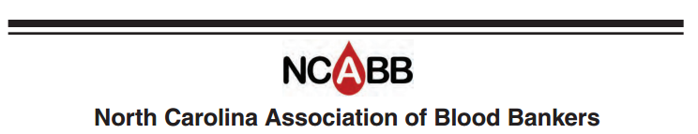

Job Description

Title: Website Chair

Term: 3 years
Elected by general membership
Has voting rights

Job Summary

- Update website periodically throughout the year. This requires larger updates before and after the Spring workshop and Fall Meeting. It also includes taking down out of date information and adding new things as needed.
- Build registration forms before each event and work with the Treasurer to ensure payments are processed appropriately.
- Work with New Media web designer to implement larger changes to the website.
- Reply to all inquiries made through the contact us page, or forward inquires to another board member as needed.
- Make sure the invoice bill for website hosting is forwarded to the treasury twice per year.
- Provide a summary website updates/changes at board meetings.
- Ensure that all links are functioning at least once per month, and fix non-functioning links and problems with the website as they arise.
- Attend board meetings usually four per year: September, January, April, and July.
- Make and vote on motion presented at board meetings.
- Conduct business in accordance with By-laws of the NCABB.
- Serve on committees as requested.

