North Carolina Association of Blood Bankers

Thank you for registering for the 46th Annual NCABB Fall Meeting.
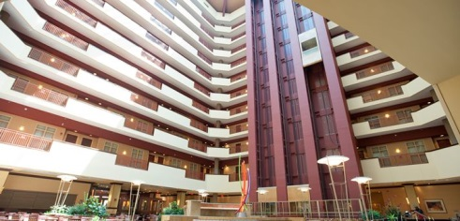
Visit our website, www.ncabb.org for access to hotel information and a preliminary agenda.

When: September 9-11th, 2018

Where: Embassy Suites by Hilton Charlotte Concord Golf Resort & Spa
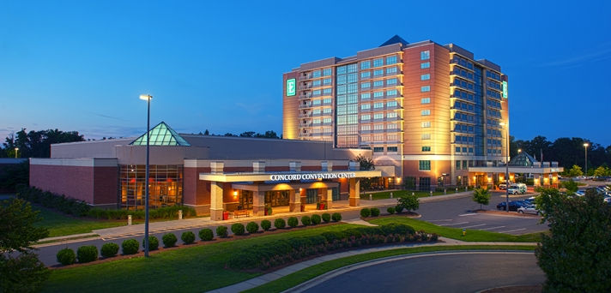
5400 John Q. Hammons Drive NW
Concord, North Carolina, 28027
USATEL: +1-704-455-8200

Guests may book their hotel reservations by either:
- Going online to http://embassysuites3.hilton.com/en/hotels/north-carolina/embassy-suites-by-hilton-charlotte-concord-golf-resort-and-spa-CLTCCES/index.html
1. Make a Reservation
2. Select Dates of your stay
3. Add Special Rate Codes
4. Group Code: ABB.
- Calling the hotel direct @ 704 455 8200 and speaking to our reservations department; please give the agent the dates needed and your group, ABB.
- Calling 1 800 362-2779 and let the reservationist know that you’re looking to book with the group code ABB and for what dates.
- Use the following URL to book directly into your group block: https://secure3.hilton.com/en_US/es/reservation/book.htm?execution=e1s1

The deadline for making reservations is midnight on 08/17/2018.
**Any requests after this date or after the block has been filled will be taken on a rate and availability basis.

