North Carolina Association of Blood Bankers

Thank you for registering for the 46th Annual NCABB Fall Meeting.
Visit our website, www.ncabb.org for access to hotel information and more information.
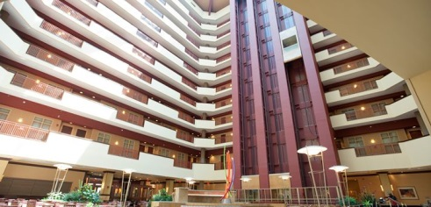
For Questions, contact Lindsey Lima at Lhrichak@gmail.com

When: September 9-11th, 2018

Where: Embassy Suites by Hilton Charlotte Concord Golf Resort & Spa
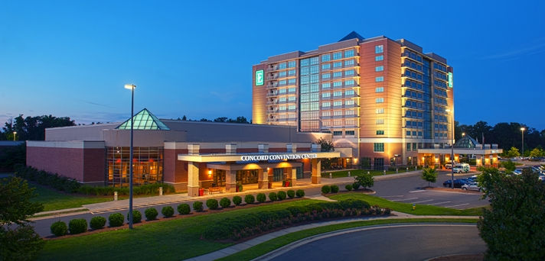
5400 John Q. Hammons Drive NW
Concord, North Carolina, 28027
USATEL: +1-704-455-8200

Guests may book their hotel reservations by either:
- Going online to http://embassysuites3.hilton.com/en/hotels/north-carolina/embassy-suites-by-hilton-charlotte-concord-golf-resort-and-spa-CLTCCES/index.html
1. Make a Reservation
2. Select Dates of your stay
3. Add Special Rate Codes
4. Group Code: ABB.
- Calling the hotel direct @ 704 455 8200 and speaking to our reservations department; please give the agent the dates needed and your group, ABB.
- Calling 1 800 362-2779 and let the reservationist know that you’re looking to book with the group code ABB and for what dates.
- Use the following URL to book directly into your group block: https://secure3.hilton.com/en_US/es/reservation/book.htm?execution=e1s1

The deadline for making reservations is midnight on 08/17/2018.
**Any requests after this date or after the block has been filled will be taken on a rate and availability basis.

