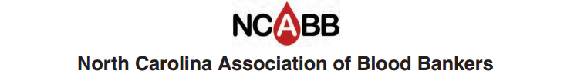

Job Description

Title: Board Member

Term: Staggered Terms - 6 Total Board Members (Two 1-yr, Two 2-yr, Two 3-yr)
Elected by general membership
Has voting rights

Job Summary

- Attend board meetings, usually four per year: September, January, April, and July

- Make and vote on motions presented at board meeting.

- Conduct business in accordance with By-laws of the NCABB.

- Attend general business meeting during fall seminar.

- Serve on committees as requested.

