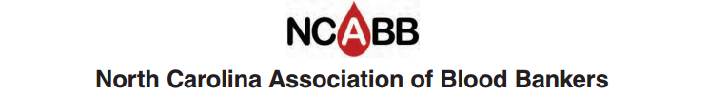

Job Description

Title: Education Chair

Term: 3 years
Elected by general membership
Has voting rights

Job Summary

- Attend board meetings, usually four per year: September, January, April, and July
- Make and vote on motions presented at board meeting.
- Conduct business in accordance with By-laws of the NCABB.
- Attend general business meeting during fall seminar.
- Serve on committees as requested.
- Receive approval by P.A.C.E. as a Program Administrator (via one or more of the following routes)
- is or has been a director or coordinator of an accredited program in the clinical laboratory sciences,
- hold a degree in education or laboratory science
- has sufficient teaching experience, or experience in educational program planning in the clinical laboratory sciences
- has participated in a workshop or course in educational methodologies
- has attended the PACE session held annually at the ASCLS National Annual Meeting
- Must fill out PACE application yearly (approval is valid Jan 1 - Dec 31).
- Ensure meeting programs meet PACE guidelines, once PACE accreditation is established.
- Disseminate program information to speakers and participants in a timely manner.
- Determine contact hours for program sessions.
- Review meeting programs for PACE acceptance.
- Develop PACE acceptable attendance roster, evaluation forms, and certificate.
- Verify attendance and sign all certificates at the meetings.
- Collect roster sheets and evaluation forms at the meetings.
- Summarize evaluations and record on roster sheet.
- Submit quarterly reports (within 30 days of end of quarter) that include quarterly activity form, attendance forms, evaluation summaries, and program information.
- Keep all copies of attendance rosters, evaluation summaries, and program information for 5 years.
- Submit request for PACE stickers if needed.

